House Price Prediction using Linear Regression
Course: Artificial Intelligence & Machine Learning – Task 1
Name: Aashu Kashyap

1. Objective
The goal of this project is to build and evaluate a Linear Regression model to predict house prices using the California Housing dataset.

2. Dataset
- Source: California Housing dataset (Scikit-learn)
- Shape: 20,640 rows × 9 columns
- Features: Median Income, House Age, Average Rooms, Average Bedrooms, Population, Average Occupancy, Latitude, Longitude
- Target Variable: Median House Value (Price)

3. Exploratory Data Analysis (EDA)
Descriptive Statistics
The dataset contains continuous variables with no missing values.
Distribution Plots
sandbox:/histogram.png (Histograms show skewness in Median Income and Average Rooms, while Latitude and Longitude reflect geographical spread.)
Correlation Heatmap
sandbox:/heatmap.png (Strong positive correlation between Median Income and House Price; weak correlation for Population and Longitude.)

4. Model Development
- Train-Test Split: 80% training, 20% testing
- Algorithm: Linear Regression (Scikit-learn)
- Training: Model fitted on training data
- Prediction: Generated on test set

Workflow Diagram
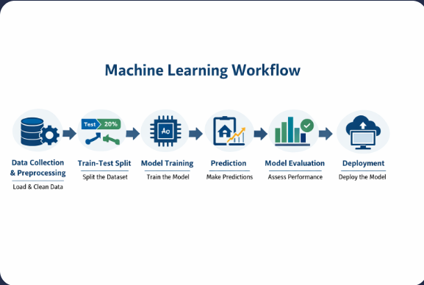

5. Model Evaluation
Metric | Value
MAE | 0.5332
MSE | 0.5559
RMSE | 0.7456
R² | 0.5758
Actual vs Predicted Prices
sandbox:/actual_vs_predicted.png (Scatter plot shows moderate alignment between predicted and actual values.)
Residual Plot
sandbox:/residuals.png (Residuals are centered around zero, but variance increases with higher predicted values.)

6. Conclusion
The Linear Regression model achieved an R² score of 0.5758, explaining ~57.6% of the variance in house prices. While this demonstrates reasonable predictive capability, further improvements are possible.

7. Future Improvements
- Feature Engineering
- Outlier Removal
- Hyperparameter Tuning
- Comparison with advanced models (Random Forest, XGBoost, Gradient Boosting)
- Deployment via Streamlit Web Application

8. Model Deployment
The trained model was saved using Pickle for future use:
python
import pickle
pickle.dump(model, open("house_price_model.pkl","wb"))

